**User guide of the code for**

**multi-modal image processing pipeline**

1. **Code list**
   1. **Entrance code**
2. A01_ReconMain

The entrance code for image reconstruction includes fluorescence deconvolution, phase retrieval, and multi-tile stitching.

1. A02_Multicycle_Alignment

The entrance code for multi-cycle alignment.

1. A03_Multimodel_Registration

The entrance code for the registration between H&E image and fluorescence image.

* 1. **Functions**

1. F00_FluoAndPhaseRecon
2. F01_DeconFluorPart

The function of region-based deconvolution of fluorescence images.

1. F02_DeconPhasePart

The function of region-based retrieval of quantitative phase image.

1. F03_StitchTiles

The function of phase-image based multi-tile stitching.

1. F11_LRDeconv

The function of Richardson-Lucy deconvolution of fluorescence images.

1. F11_WBDeconv

The function of Wiener-Butterworth deconvolution of fluorescence images.

1. F12_ReadImgStack

This function reads and returns the image stack.

1. F13_Preprocess

This function finds the background level of the image and removes it from the image.

1. F14_FluoFocusFourierFull

This function finds the focal plane of the fluorescence image stack according to the ratio between the high and low frequency components in frequency domain.

1. **Format of the data name**

The example data that accompany this code for the image processing pipeline is available in the “Example_data” folder at <https://doi.org/10.5281/zenodo.14838554>.

This code also requires a set of self-generated correction maps for flat-field correction. The detailed steps are described in the method section of the manuscript. The example correction map from our system is provided at under “Correction_maps” folder at <https://doi.org/10.5281/zenodo.14838554>.

The code is designed for multi-layer reconstruction, multi-tile stitching, and multi-cycle registration. To distinguish the images, it is crucial to define the names of the image files using a specific format: ‘(predefined name)_Cy+(cycle number)_Ro+(row number)_Co+(column number)_La+(layer number)_Ex+(excitation wavelength)_Em+(emission wavelength)’.

For example, the fluorescence image ‘SW480_Cy1_Ro1_Co1_La2_Ex589_Em615.tiff’ has a corresponding bright-field image for phase retrieval named ‘SW480_Cy1_Ro1_Co1_La2_Ex000_Em615.tiff’.

* **For the fluorescence image:**
  + ‘SW480’ is the predefined name, usually describing the experimental target.
  + ‘Cy1’ defines the cycle number, indicating the 1st cycle.
  + ‘Ro1_Co1’ defines the tile information, with Ro1 representing the 1st row and Co1 representing the 1st column.
  + ‘La2’ defines the layer information, with La2 indicating the 2nd layer.
  + ‘Ex589_Em615’ defines the excitation and emission wavelengths, with the excitation wavelength being 589 nm and the emission wavelength being 615 nm.
* **For the bright-field image:** The only difference between the bright-field image and the corresponding fluorescence image is that the excitation wavelength is set to ‘Ex000’.

1. **Image reconstruction, multi-tile stitching**

Run ‘A01_ReconMain’ to reconstruct fluorescence and quantitative phase images, and stitch multi-tile images into a whole-slide image.

After running the code, a dialog will pop up, allowing the user to select the data to be reconstructed. The code will automatically estimate the number of channels and tiles based on the information in the data names. It will then apply region-based deconvolution to the fluorescence images and retrieve the quantitative phase images.

After reconstruction, the multi-tile images in each channel will be stitched together to create a whole-slide fluorescence and phase image.

The overall workflow of image reconstruction and stitching is shown in Fig. 1.

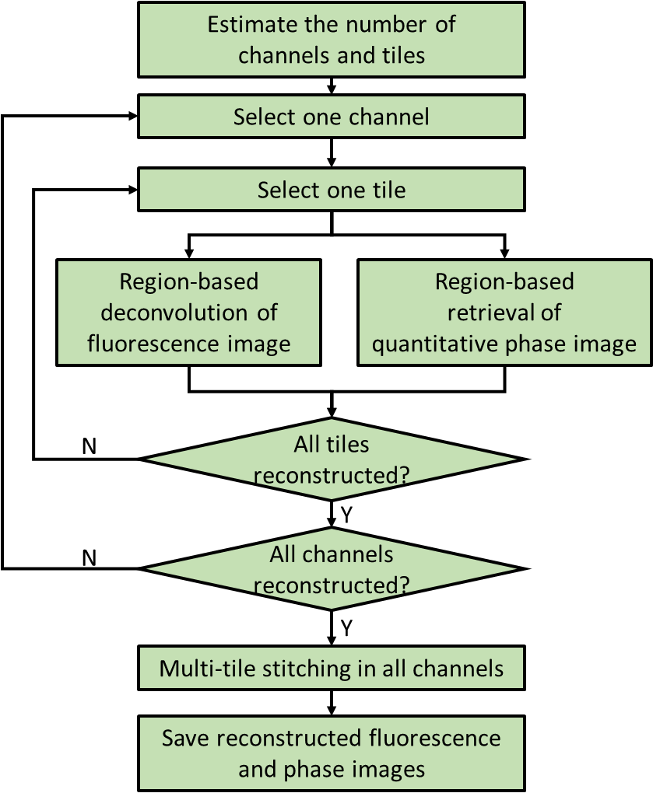

**Fig 1. Overall workflow of image reconstruction and stitching**

1. **Multi-cycle alignment**

Run ‘A02_Multicycle_Alignment’ to align the images from different cycles. The images from the first cycle are used as references, and all subsequent cycles are registered to the first cycle.

Larger feature numbers may improve registration accuracy but will consume more memory. To balance accuracy and efficiency, we adjust the metric threshold so that the feature number remains between 1,000 and 10,000.

The workflow for multi-cycle alignment is shown in Fig. 2.

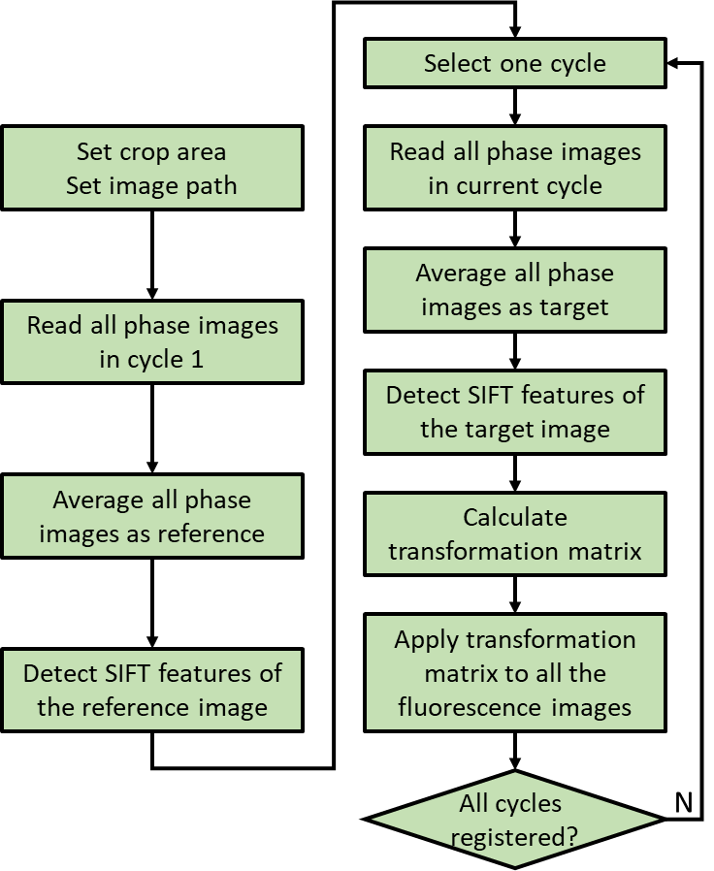

**Fig 2. Workflow of multi-cycle registration**

1. **Multi-model registration**

Run ‘A03_Multimodel_Registration’ to align images from different models.

To improve registration speed, rotate the fluorescence image so that its orientation matches that of the H&E image.

The workflow for multi-model registration is shown in Fig. 3.

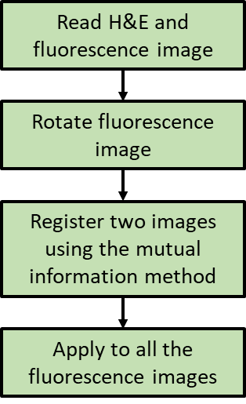

**Fig 3. Workflow of multi-model registration**